**AUTOMATION TO UPLOAD THE FILES DAILY BACKUP  
  
Step 1:**  
Download the PowerShell script attached to the email.

Replace the local directory path in the script with the path of the directory you want to upload to the centralized storage.  
  
save the file

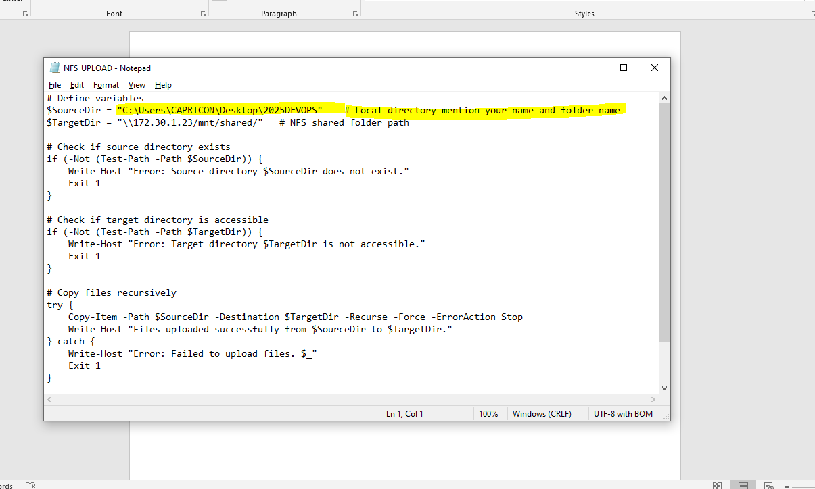

Step 2  
Open the task schedular  
  
  
  
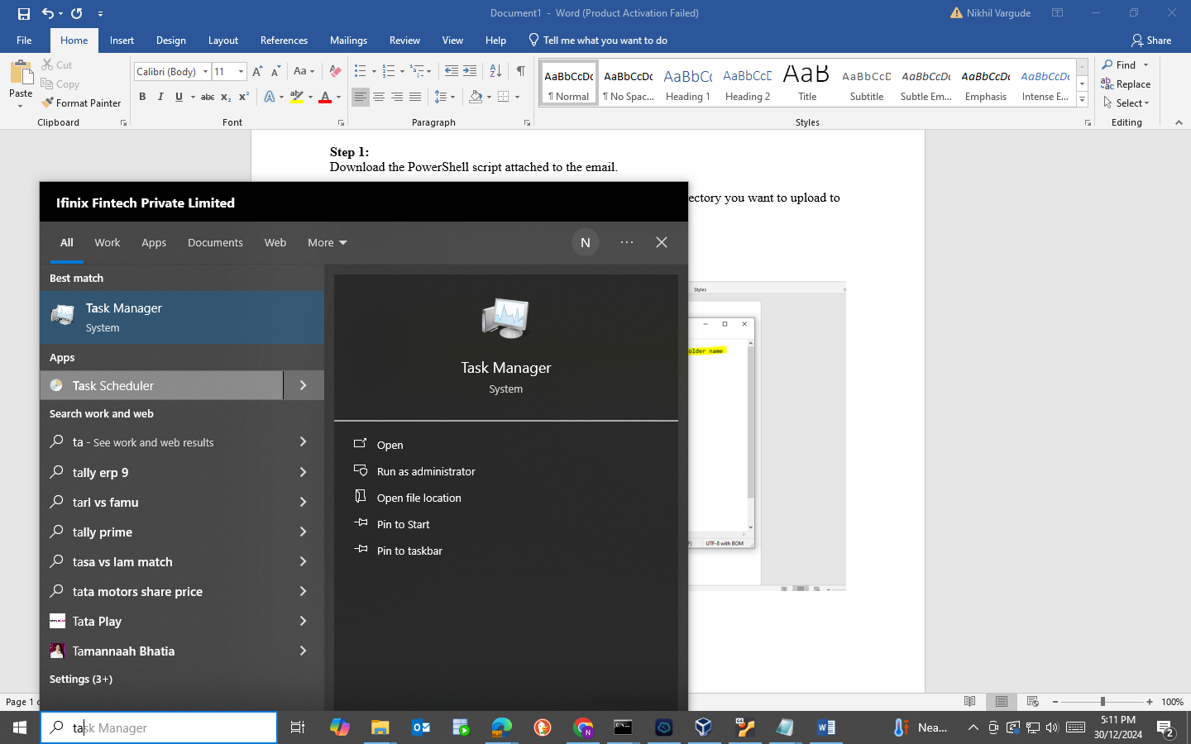

• In the right pane, click on **Create Basic Task**.

• **Name the Task:**

* In the **Create Basic Task Wizard**, provide a name for the task (e.g., **"Upload Files to Centralized Storage"**).
* Optionally, add a description for the task.
* Click **Next**.

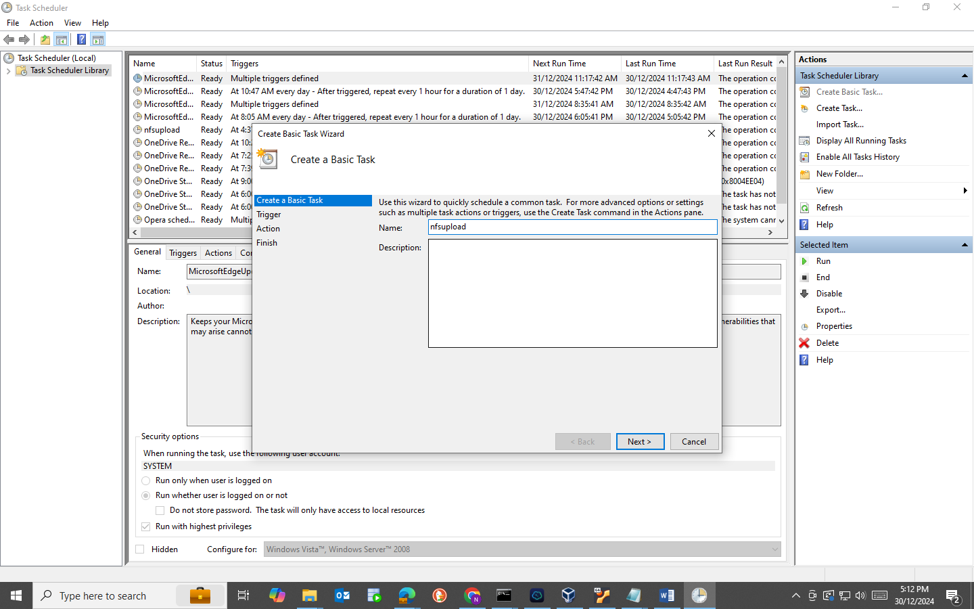  
  
• **Select Daily:**

* Choose **Daily** as the trigger.
* Click **Next**.

• **Set Start Date and Time:**

* Set the desired start date and time for the task to run daily.
* Click **Next**.

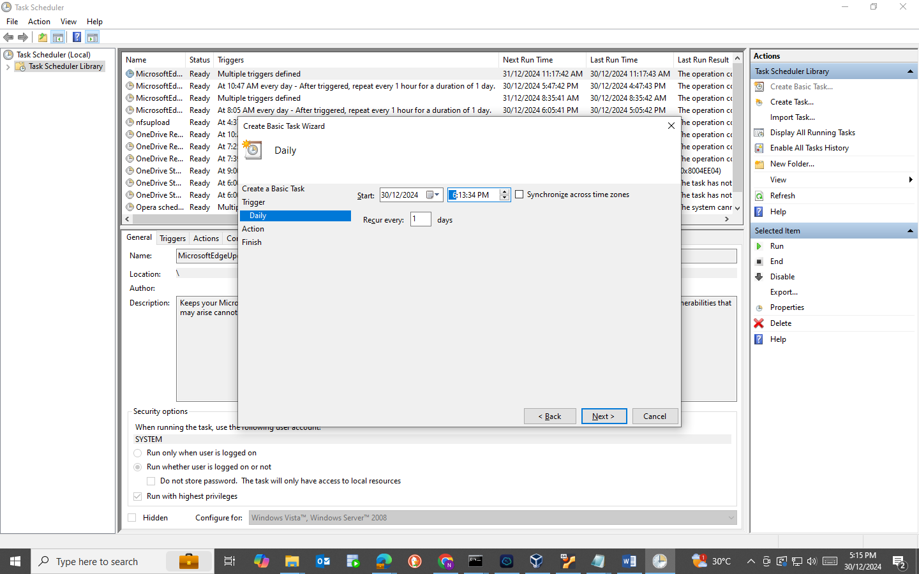

**Choose Action:**

* Select **Start a Program**.
* Click **Next**.

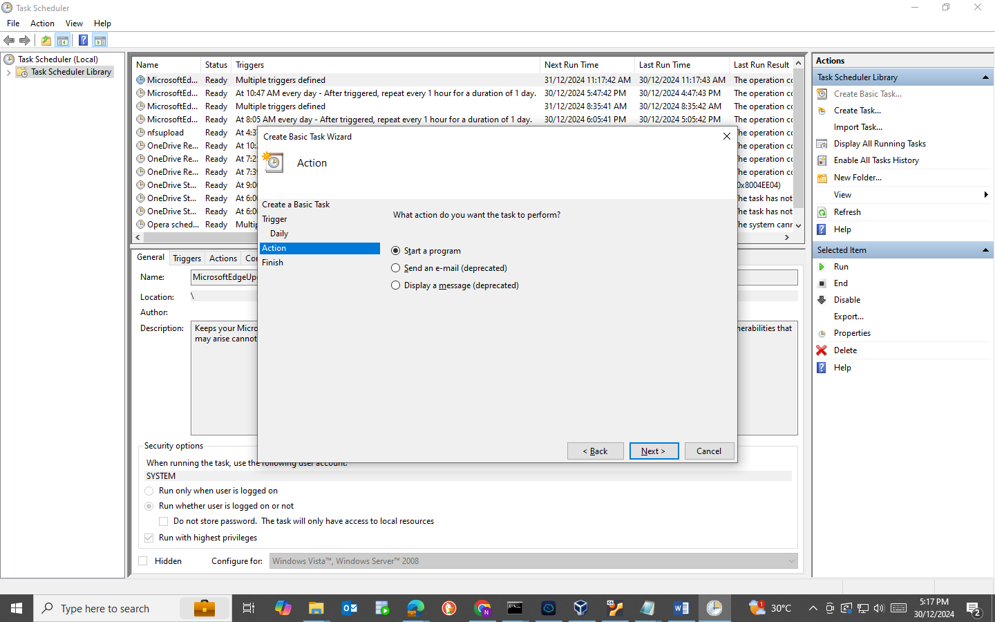  
  
Please specify the full path of the PowerShell script you downloaded from the email, such as "C:\Users\YourUsername\Downloads\NFS_UPLOAD". 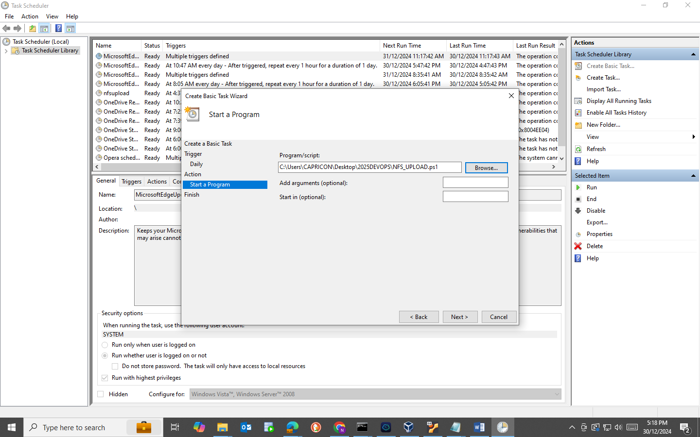

Next and Finished